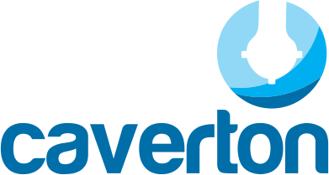

CAVERTON OFFSHORE SUPPORT GROUP
UNAUDITED CONSOLIDATED RESULTS
FOR THE FIRST QUARTER, (THREE MONTHS), ENDED 31ST MARCH, 2017

The Board of Directors, (‘’the Board’’), of Caverton Offshore Support Group, (‘’the Group), hereby announces the following Unaudited Results for the First Quarter, (three months), ended 31st March, 2017:

Income Statement
The Group The Company
31-Mar-17 31-Mar-16 31-Mar-17 31-Mar-16
N'000 N'000 N'000 N'000

Revenue 5,104,434 4,415,640 - -
Operating expenses (3,461,952) (2,914,564) - -
Gross Profit 1,642,482 1,501,076 - -
Administrative expenses (920,340) (1,083,337) (34,690) (50,397.00)
Other operating income 69,499 120,966 - -
Total Operating Profit 791,641 538,705 (34,690) (50,397.00)
Finance cost (436,258) (329,959) (2) 243.00
Profit for the period before income tax 355,383 208,746 (34,692) (50,154.00)
Income tax expense (140,564) (99,159) (4,188) -
Profit for the period 214,819 109,587 (38,880) (50,154)

Profit attributable to:
Owners of the Company 212,671 108,491 (38,491) (49,652)
Non-controlling interests 2,148 1,096 (389) (502)
Profit for the period 214,819 109,587 (38,880) (50,154)

Basic Earnings per share (N) 0.06 0.03 (0.01) (0.01)
Number of Shares in issue 3,350,509,750 3,350,509,750

Comments:
A revenue increase of 16% and direct operating costs improvement by 19% support impressive earnings per share increase by 96% compared to Q1 2016. The results further highlight the commitment of streamlining our operations in the face of challenging operating business environment, as well as our continued focus on cost efficiency. The Board is very optimistic that the Group is in a good position to cope with the tough operating business conditions.

Dated the 28th day of April, 2017

By order of the Board

Amaka P. OBIORA
Company Secretary

1, Prince Kayode Akingbade Close, Victoria Island, Lagos.

The detailed Financial Statements for the period are available on the company’s website,
www.caverton-offshore.com

