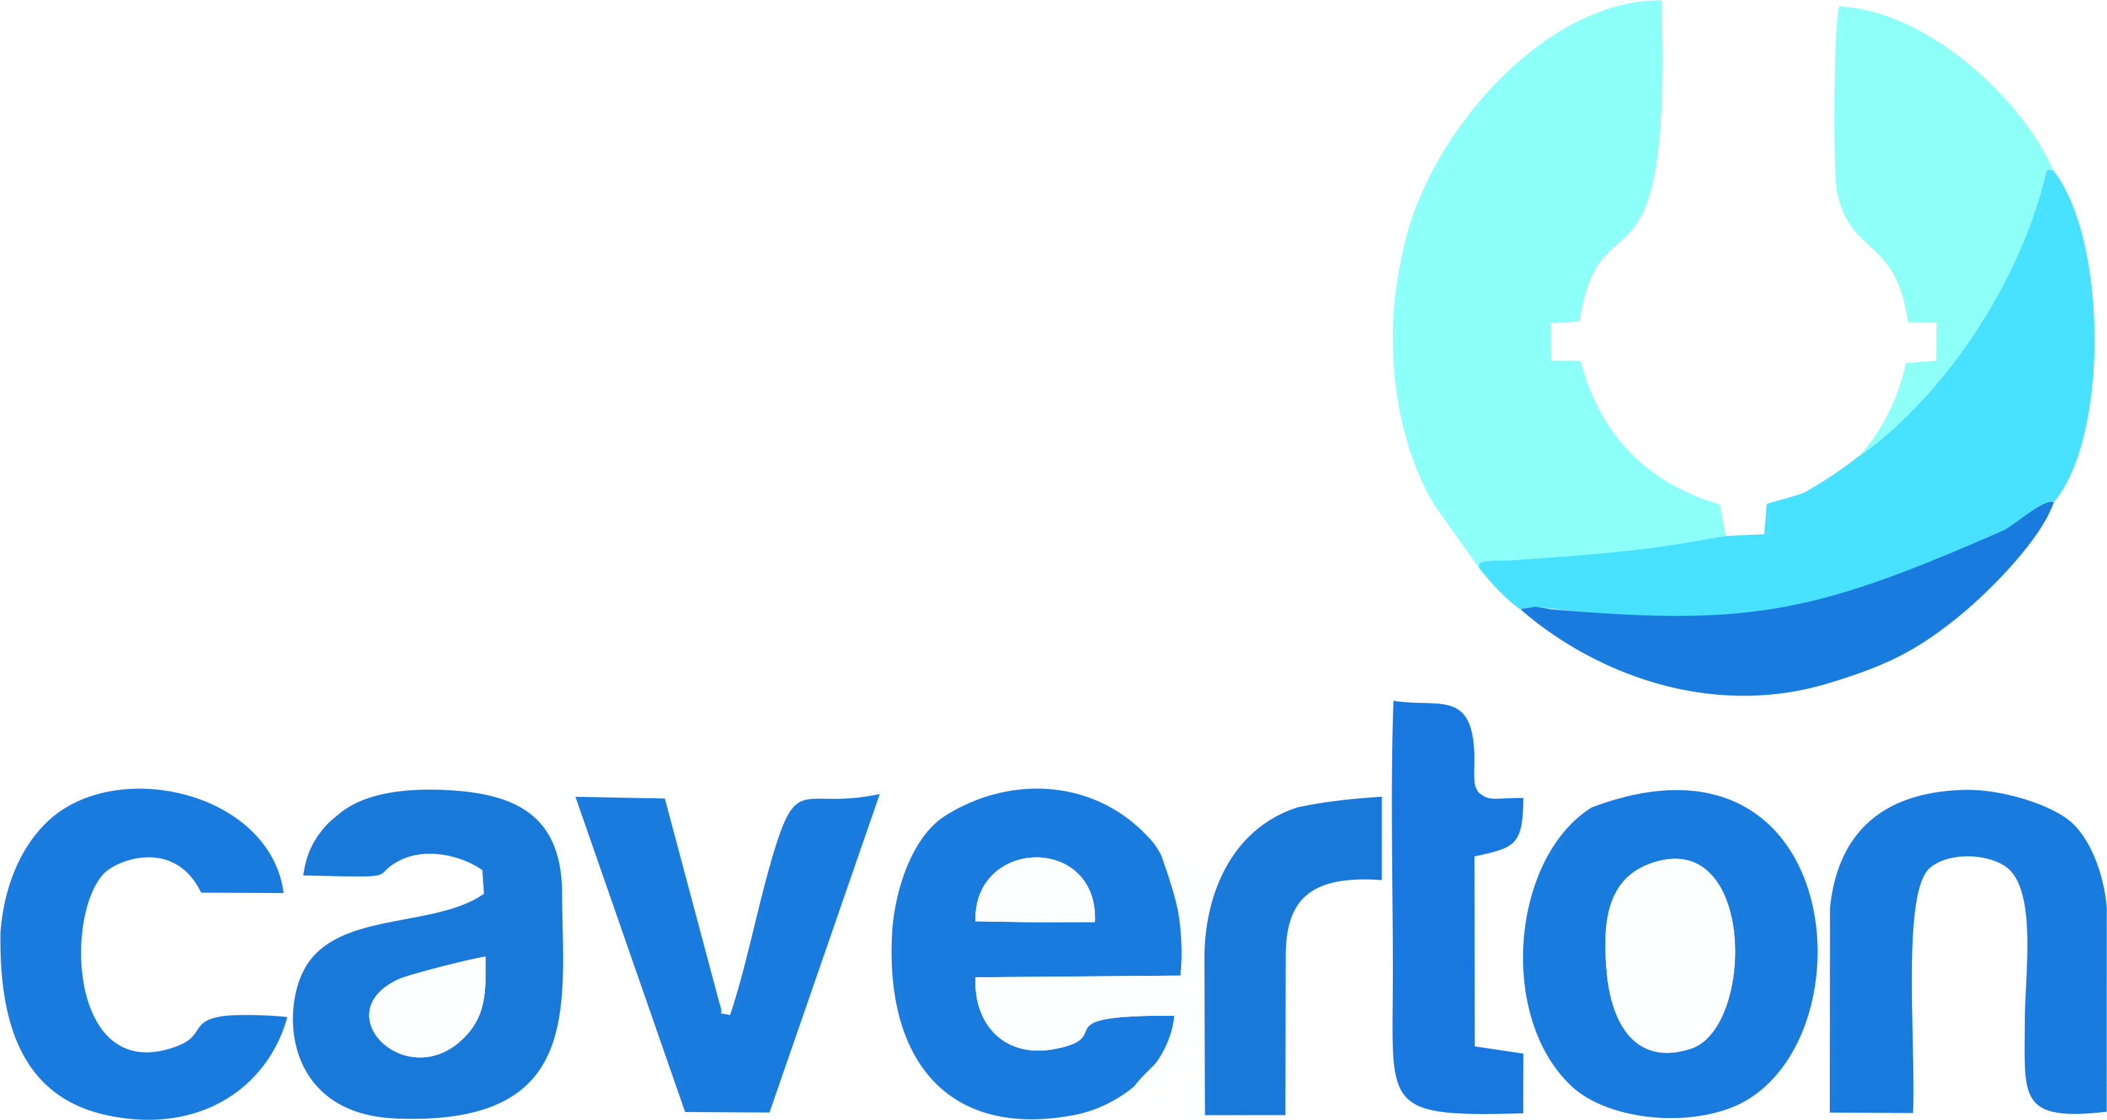

Lagos, Nigeria: 10 March 2020
PRESS RELEASE ON LATE SUBMISSION OF AUDITED FINANCIAL STATEMENT FOR THE YEAR ENDED 31ST DECEMBER, 2019
The Board of Directors and Management of Caverton Offshore Support Group Plc (“COSG or the Company”) hereby notifies its esteemed shareholders and other stakeholders with regret that the Company may be unable to submit its 2019 audited financial statements to The Nigeria Stock Exchange (The Exchange) within the regulatory timeframe of 30 March 2020.
This delay had been unanticipated as the Company had expected to finalize the audit and publish its 2019 audited financial statements on or before March 30, 2020. The reason for the anticipated delay in filing the 2019 audited financial statements is to enable the External Auditors finalize the audit of the Company’s foreign subsidiaries which require enhanced disclosure of information and consolidation into the 2019 audited financial statements.
COSG sincerely apologizes for any inconvenience this delay might cause and is optimistic that the 2019 audited financial statements will be submitted to The Exchange on or before 30th April, 2020.
This information can also be found on the company’s website: www.caverton-offshore.com
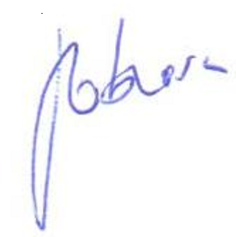
AMAKA OBIORA
Company Secretary
FRC/2015/NBA/00000011302
1, Prince Kayode Akingbade Close, Victoria Island

